Pentre Mawr, Abergele : Sunday 8th February 2026
General : Event utilising the town park of Pentre Mawr in Abergele. As this is a public park there are likely to be other users, primarily children, dog walkers and runners. Please take care and respect the shared use.
Location : Post code LL27 7PL. What3words :///words.chucked.dampen. Vehicle access to the park is off Dundonald Road. There is limited parking on site with alternative parking along Sea Road or on the promenade (with a short walk of 500m to the park). Please drive carefully in the park as you will likely encounter park users.
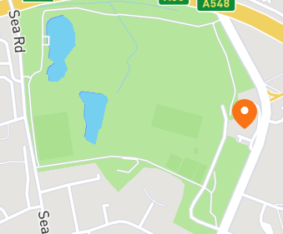
Event base
Vehicle access to the park
The event base will be a tent located near to the cricket pavilion.: start/finish/general information
Map: The map has been recently updated at a scale of 1:4000. There is no climb.
Courses : There will be Yellow, Orange and Light Green courses
Start times: 10.30am until 12.30pm
Controls : SI will be used. SI cards will be available to hire ; £30 if it's not returned
Entries : Are via https://pre-entries.co.uk/dl/events. Entries close Wednesday 4th February 2026. There will be limited entry on the day if maps are available (correct cash only please).
Toilets : Unfortunately the public toilets within the park are now closed. The nearest public toilets are on the promenade.
Newcomers : As this event is suitable for those new to orienteering there will be opportunity for some instruction and assistance.

